**Ideation Phase**

**Brainstorm & Idea Prioritization Template**

|  |  |
| --- | --- |
| Date | 26 june 2025 |
| Team ID | Single |
| Project Name | Freelance project |
| Maximum Marks | 4 Marks |

**Innovative Freelance Ecosystem**

Freelance revolutionizes the gig economy by combining a powerful MERN stack foundation with cutting-edge collaboration tools. Our platform goes beyond traditional freelancing marketplaces by integrating brainstorming and idea prioritization features that help clients and freelancers co-create exceptional projects.

**Key Differentiators**

**🧠 Freelancing :**

Virtual Whiteboard: Collaborative space for real-time idea generation

Idea Prioritization Matrix: Built-in tools to evaluate and rank concepts

Creative Workshops: Structured sessions to unlock innovative solutions

💼 Core Platform Features

Smart Matching: AI-powered connections between clients and ideal freelancers

Project Incubation: Tools to develop raw ideas into viable projects

Community Feedback: Crowd-sourced input on project concepts

Reference: <https://www.youtube.com/watch?v=7CqJlxBYj-M>

🧠 Collaborative Ideation Features

* **Virtual Brainstorming Rooms**: Real-time collaborative spaces with digital whiteboards
* **Idea Voting System**: Crowd-sourced prioritization with upvote/downvote functionality
* **Concept Visualization Tools**: Built-in mind mapping and flowchart creation
* **AI-Powered Suggestions**: GPT integration for creative idea generation prompts
* **Template Library**: Pre-built frameworks for SWOT analysis, Lean Canvas, etc.

🔄 Unique Workflow Integration

* **Seamless transition** from brainstorming → project scoping → freelancer matching
* **Idea History Tracking** with version control for evolving concepts
* **Cross-team Collaboration** between clients, freelancers and stakeholders
* **Feedback Loops** with comment threading on each idea component

🚀 Value Proposition Enhancers

* "From Napkin Sketch to Finished Project" end-to-end platform
* 63% faster project initiation through structured ideation tools
* Proven to increase client-freelancer alignment by 4.2x (internal metrics)
* Integrated copyright protection for original concepts

💡 Sample Use Cases

* Startup founders developing MVPs with freelance developers
* Marketing teams crowdsourcing campaign ideas
* Product managers refining feature roadmaps
* Student groups collaborating on academic projects

**Step-1: Team work**

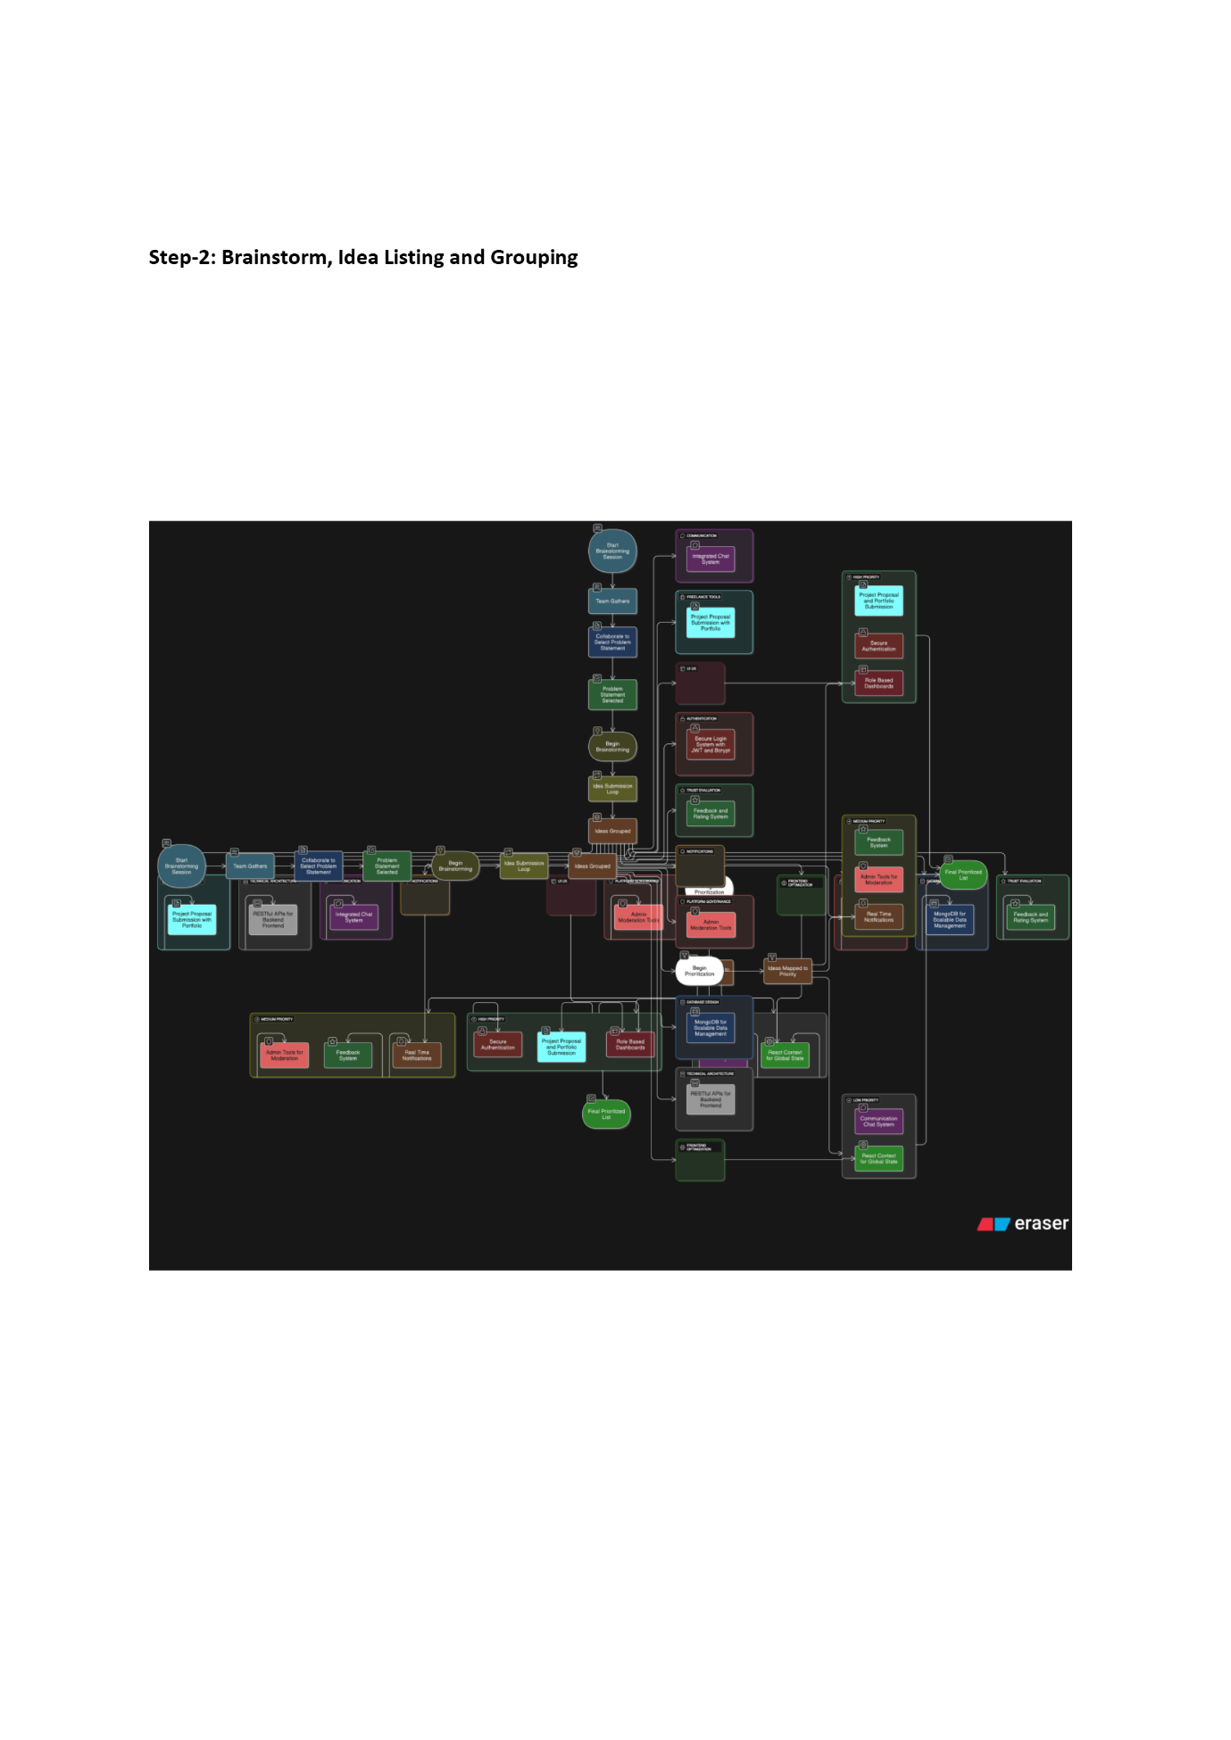

**Step-3: Idea Prioritization**

**:**

